**CASE STUDY- Business Model Documentation for Online Food Ordering Service**

**(Anand Zanwar)**

**1. Executive Summary**

This section should introduce the company, its mission, and the purpose of the business model documentation. It will highlight the growth and success of the start-up in recent months and explain the need for a clear business structure to attract investors and stakeholders.

* **Company Overview**: Describe the company, including its services (online food ordering), recent growth, and market potential.
* **Objective**: To develop a business model that supports continued growth and provides a clear, scalable structure for investors.

**2. Stakeholder Identification**

List the stakeholders involved and describe their roles in the business process.

* **Customers**: End-users who place food orders through the platform.
* **Restaurant Partners**: Businesses that list their menus and fulfill food orders.
* **Delivery Partners**: Logistics providers or individual delivery personnel responsible for delivering the orders.
* **Investors**: Potential stakeholders interested in funding the company.
* **Company Admin**: Internal users managing the platform, customer support, and operations.

**3. Requirements Analysis**

This section will delve into the core requirements of the system, gathered through stakeholder interviews, research, and observation of the current business operations.

* **Functional Requirements**:
  + Customers can search for restaurants, browse menus, and place orders.
  + Customers can make secure online payments.
  + Real-time tracking of orders and delivery.
  + Restaurants can manage menus, orders, and delivery updates.
  + Delivery personnel receive orders for dispatch and can track deliveries.
  + Admins manage overall system performance, support tickets, and monitor the business metrics.
* **Non-Functional Requirements**:
  + Scalability to handle increased user loads.
  + Security features for payments and personal data.
  + Reliability and availability, ensuring minimal downtime.
  + Integration with third-party services like payment gateways and delivery platforms.

**4. Business Processes**

A breakdown of the key business processes involved in the online food ordering service:

* **User Registration and Authentication**: Both customers and restaurants need to sign up and log in to access services.
* **Order Management**: Customers browse menus, select food items, and place orders. Restaurants receive the orders and begin preparation.
* **Payment Processing**: Secure payments processed via third-party payment gateways or integrated systems.
* **Delivery Assignment**: Once food is prepared, a delivery partner is assigned, and real-time tracking is enabled for customers.
* **Customer Feedback**: After the order is delivered, customers provide ratings and reviews.

**5. Competitor and Market Analysis**

* **Competitor Overview**: Compare the business with similar services in the market (e.g., Uber Eats, DoorDash, Zomato). Analyze their business models and revenue streams to highlight the company’s competitive edge.
* **Market Trends**: Describe the rise of online food ordering, particularly during the pandemic, and the shift towards convenience-based services. Present statistics or data that reflect user growth and potential for expansion into new markets or geographies.

**6. Revenue Model**

Explain the monetization strategies the company employs:

* **Commission-based Model**: A percentage cut from each order that goes through the platform.
* **Delivery Fees**: Charges paid by customers for delivery services.
* **Advertising Revenue**: Restaurants pay for premium listing or promotional deals on the platform.
* **Subscription Model**: Premium service for customers that could include free delivery or exclusive restaurant deals.

**7. Challenges and Risk Management**

Identify potential business and operational challenges:

* **Operational Delays**: Risk of delivery delays due to traffic or restaurant preparation time.
* **Payment Failures**: Risk of payment gateway downtime.
* **Customer Service Issues**: Addressing customer complaints about food quality or delivery time.
* **Scalability**: Growing user base might strain system performance.

Provide mitigation strategies, such as partnering with additional delivery services, optimizing the app for performance, or implementing robust customer support.

**8. UML Diagrams**

**a. Use Case Diagram**

The use case diagram illustrates the interaction between users (actors) and the system:

* **Actors**: Customer, Restaurant Partner, Delivery Partner, Admin.
* **Use Cases**:
  + Customers: Browse restaurants, place order, make payment, track delivery, provide feedback.
  + Restaurant Partners: Manage menu, receive order, update order status.
  + Delivery Partners: Accept delivery request, deliver order.
  + Admin: Monitor platform, manage users, resolve support tickets.

*Use Microsoft Visio to visually represent the actors and their interactions with the system.*

**b. Class Diagram**

This diagram shows the key entities (classes) involved and their relationships:

* **Classes**:
  + Customer (name, contact details, order history)
  + Order (order ID, order details, payment status, delivery status)
  + Restaurant (restaurant ID, menu, orders)
  + Menu (item name, price, availability)
  + Payment (payment ID, method, status)
  + Delivery (delivery ID, delivery status, assigned partner)
  + Feedback (feedback ID, rating, comments)

The diagram will include the associations between these classes, for example, a customer places an order, which includes items from a restaurant’s menu.

**c. Activity Diagram**

An activity diagram to map the sequence of actions in the order process:

* Customer selects restaurant → Customer browses menu → Customer places order → Payment processed → Order confirmed → Restaurant prepares food → Delivery assigned → Order delivered.

**d. Sequence Diagram**

A sequence diagram can show how components of the system interact over time:

* **Actors**: Customer, Restaurant, Payment Gateway, Delivery Partner.
* The sequence starts when a customer places an order and ends when the order is delivered and feedback is provided.

*Visio can be used to represent the network of interactions between these components.*

Use Case Diagram:

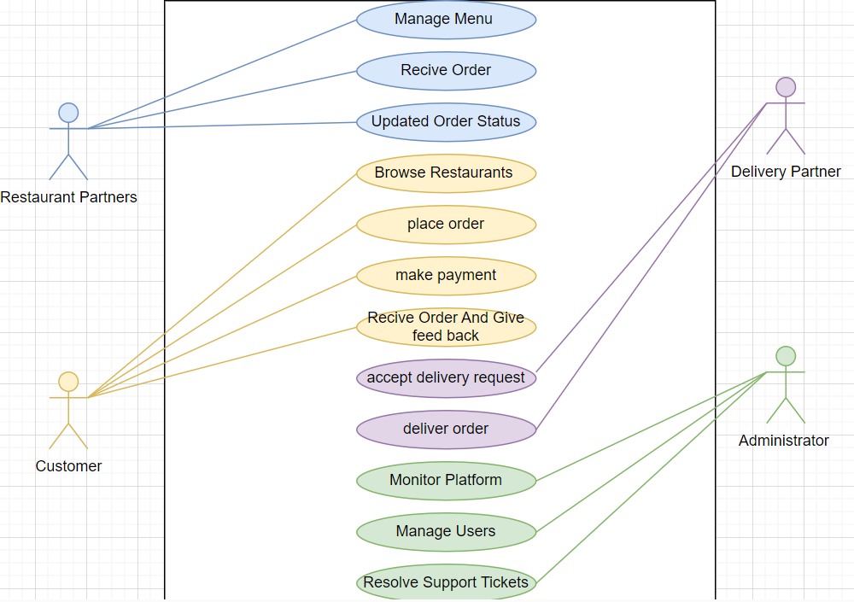

**Sequence Diagram:**

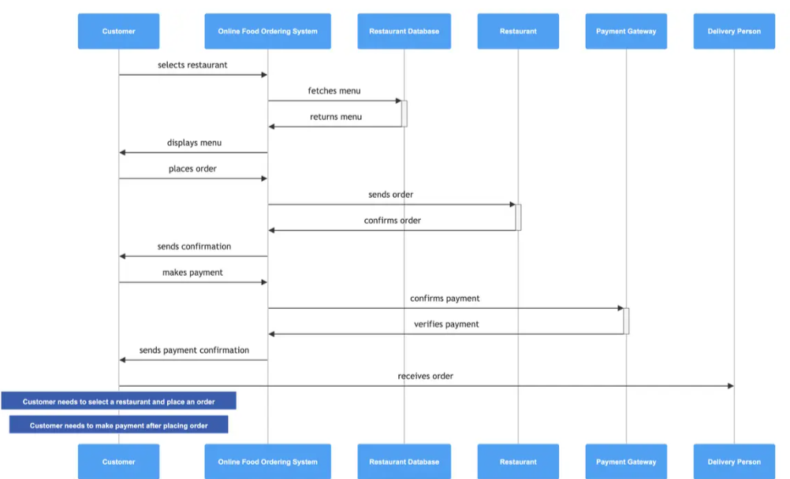

**Conclusion:**

In conclusion, the business model for our online food ordering service is designed to capitalize on the tremendous growth and user adoption seen in recent months. By streamlining operations, enhancing user experience, and utilizing scalable technology, we are well-positioned to meet increasing market demand. The model outlines efficient workflows for order processing, payment integration, and delivery management, ensuring seamless interactions between customers, restaurant partners, and delivery personnel.

The use of UML diagrams, such as the Use Case, Class, Activity, and Sequence Diagrams, clearly demonstrates the functionality and interaction of different system components, providing a transparent and well-structured framework for stakeholders. These diagrams help visualize the flow of operations and offer insights into how the system can be expanded to accommodate future growth.

By addressing potential risks and implementing strategies for monetization, we are creating a solid foundation for sustainable success. This document, combined with our competitive positioning and market analysis, should give investors and stakeholders confidence in the long-term viability and profitability of the company. Our ability to adapt to market trends, offer a user-friendly platform, and explore new revenue streams sets us apart from competitors and highlights the potential for continued growth.

We believe this business model will attract the attention of investors, enabling the company to scale its operations and dominate the online food ordering industry.